Jasmine Store

Web programming class project 2021/2022

|  |  |  |  |  |
| --- | --- | --- | --- | --- |
| Student Name in English | Student Name in Arabic | Student ID | Section | Work percentage |
| Kenana Khalid Turabi | كنانه خالد ترابي | 11923807 | 9:30-11 | 50% |
| Baraa Bashar Khalaf | براء بشارخليفه | 11923511 | 8:00-9:30 | 50% |
|  |  |  |  |  |

Date/time

---------------------------------------------This section is intended for the Instructor---------------------------------------

|  |  |
| --- | --- |
| **Topic** | **Mark** |
| Project Idea |  |
| Project Complexity |  |
| Project Tools |  |
| Project Requirements and Modeling |  |
| Project Discussion |  |
| Project Completeness |  |
| Project Output Results or reporting |  |
| Project Administration and Management |  |
| Project Report |  |
| Team work |  |
|  |  |
|  |  |
|  |  |
|  |  |
|  |  |

**Contents:**

Cover page …………………………………….. 2

Abstract…………………………………….……3

Introduction.......................................................................3

Project Requirements …………..…………………4

Tools used in the project……………..…………5

Project UML …………….…………………...….6

Discussionabout the project GUI.............................7

Conclusion……………………..…………….....21

References….…………………………….……..21

**Abstract :**

Our purpose was to utilize what we have learned during the semester to create a completely website (Back end & Front end ) We decided to make an online store website by using html, css, javascript, php, jQuery ,bootstrap and MySql for Data Base ,DDL & DML as SQL commands to do some operations on the data.

**Introduction :**

We made an website which aims to create interactive medium between admin who offers products for women and men and users how wants to buy this products . This application saves your time since instead of going to the shop you can buy what you like from home also this website always offers features or discounts on some products.

When the user likes a product the product will be moved to the user cart and to buy the product user should confirm the operation by completing a form for shipping which is provided from the website for free .

Our website provides the users products from many famous brands .Also the products Belongs to categories : Men , Women ,Accessories, shoes and watches.

**Project Requirements :**

Jasmine Store website controls the operation of offering products from admin and buying them from people who wants these products. The Jasmine Store website has Admin whose main job is to offer products and discounts and answer users queries from contact page . Admin information are: name, ID, E-mail, password .

The store has many users. The user main information are: name, ID, E-mail, password. Those users can buy products, each product must belong to category. We have 5 categories : women, men, accessories watches and shoes, but the category can contains many products . The category main information are: name, id.

Each product has name, description, id, price, category id and picture. When the user likes a product the product will moves to the user cart table which includes product-ID, price , product name , quantity, cart_id , buyer_id . and to buy the product user should confirm the operation by completing a form for shipping.

Buy operation information will be store in shipping table . Its main information are cart_id, user address, phone number and shipping id.

**Tools used in the project:**

* PhpStorm 2021.2.1
* XAMPP
* Visual Studio Code
* PhpMyAdmin
* Drawio for EER diagram.
* Bootstrap
* jQuery
* Bootstrap
* Fontawesome-8.9
* PhpMailer

**Project UML :**

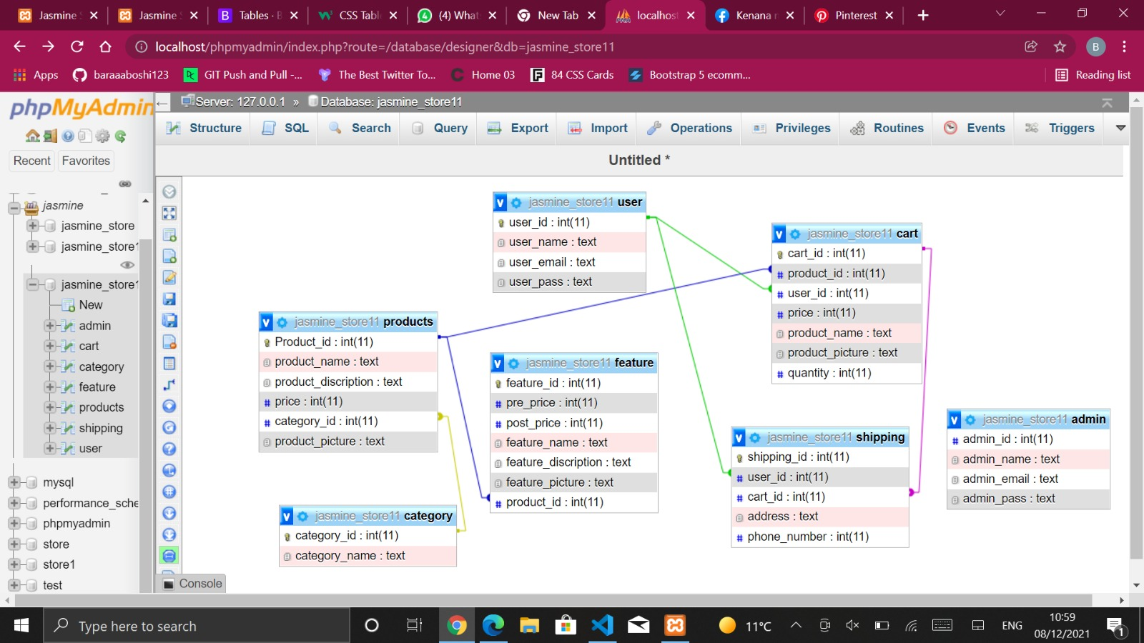

**GUI:**

* User/Admin Login Screen: If the User has an account he/she has to type email & password to enter the website .

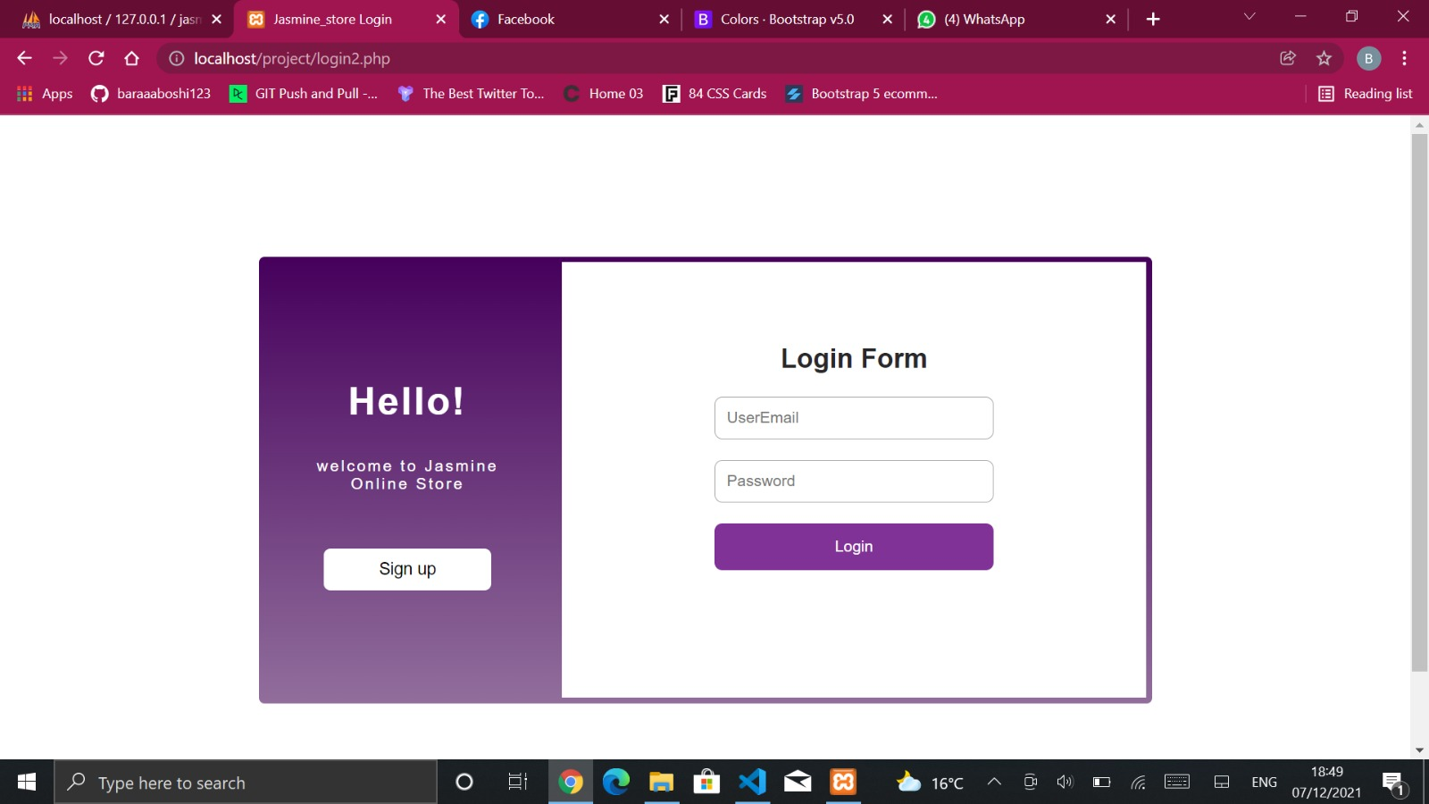

If the entered data not correct an message will appear as shown below

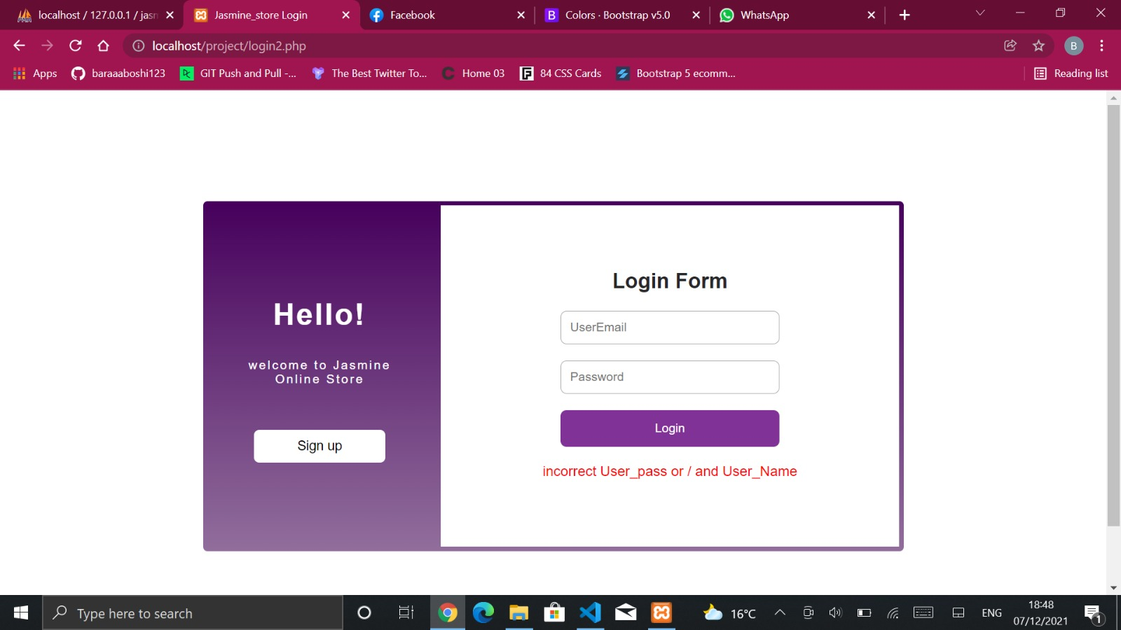

* User Sign Up: If the user does not have an account and he/she wants to create an account he/she should insert the required information as shown below .

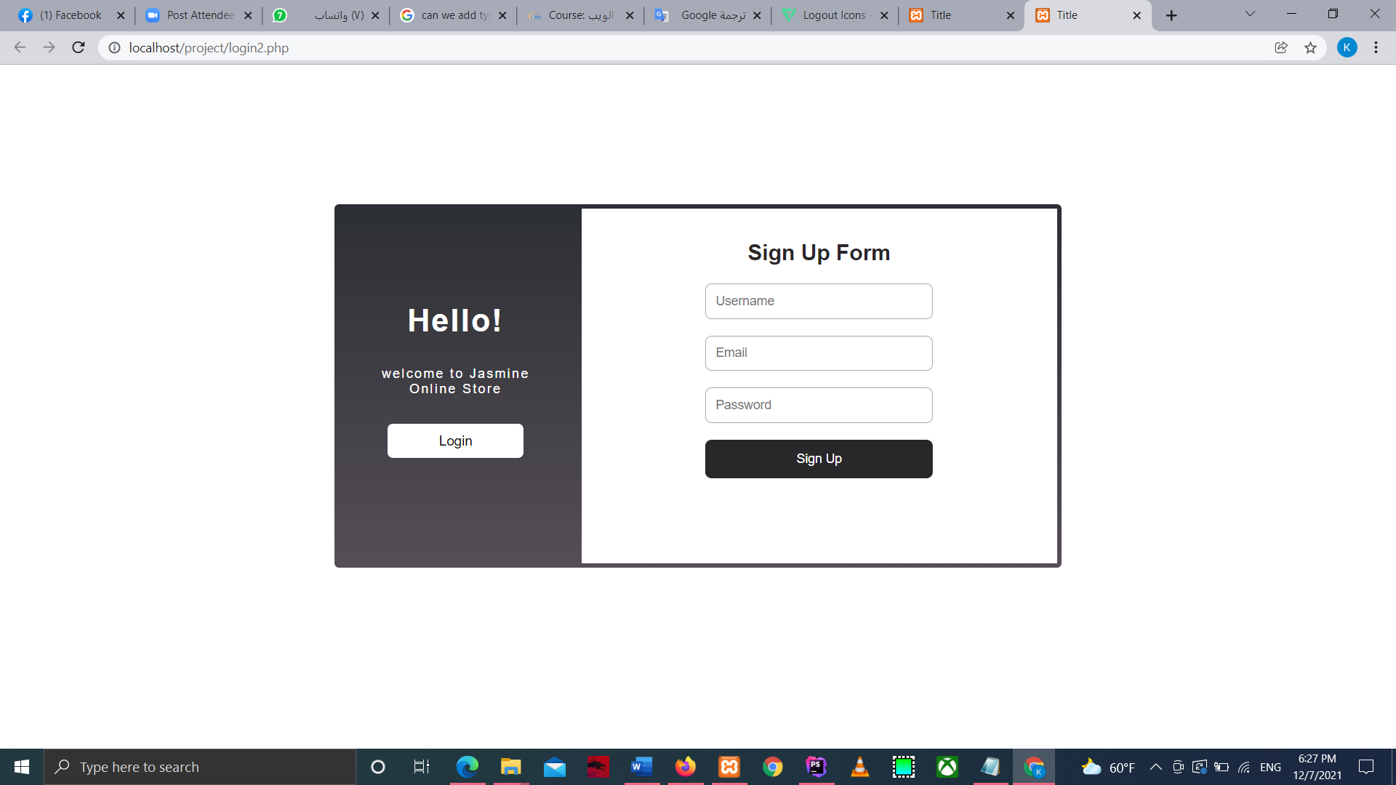

* After user login user page will be opened : which contains
* Header : Header consist of navbar which works as menu because it takes the user to Home page, shop page , shows him/her Features (discounts) , Information about the store and allows him/her to contact with the website .The navbar color is transparent but when we scroll down its color will change to black .The navbar contains 2 icons also the 1st one is cart and the 2nd is logout. The navbar exists in all pages .Also the header has carousel with 3 pictures .

**1st picture**

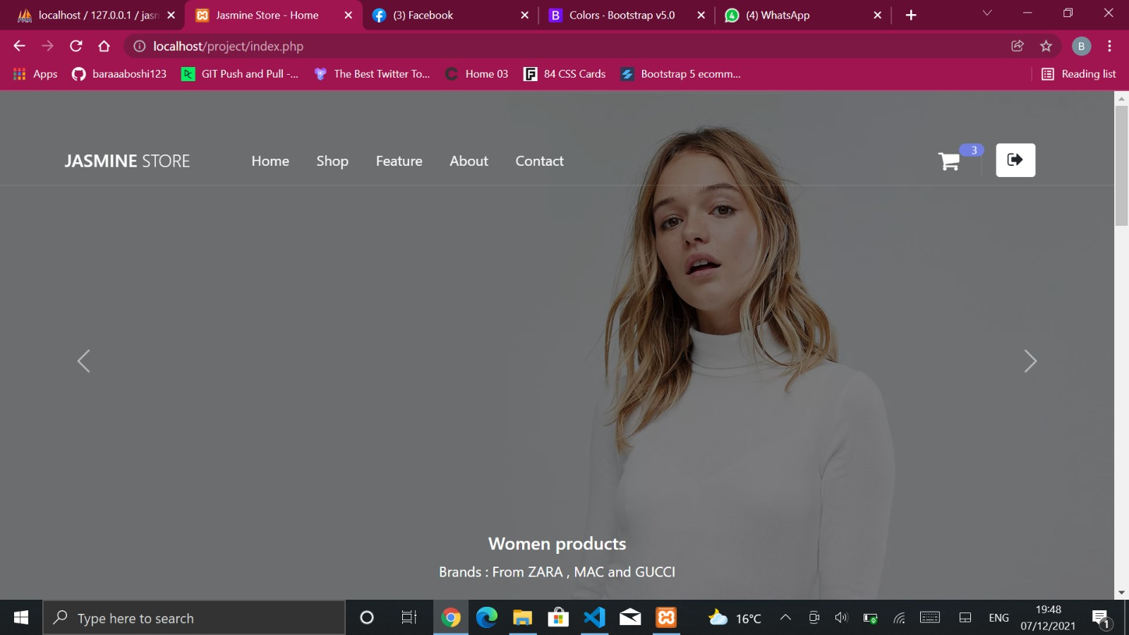

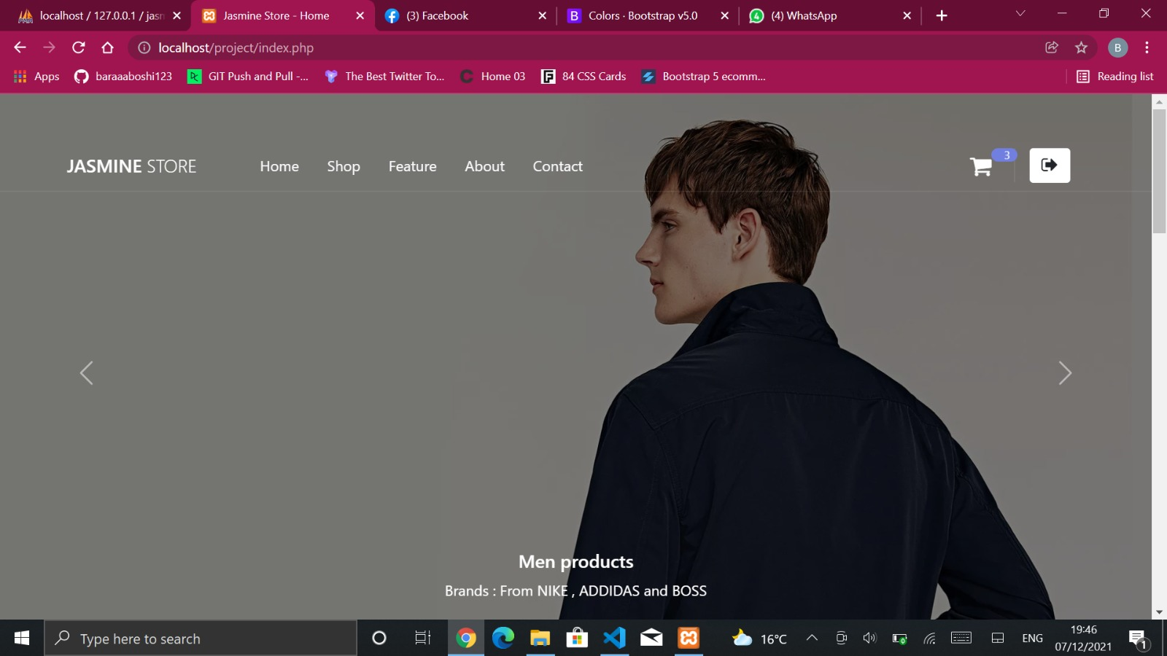

**2nd picture**

**3rd picture**

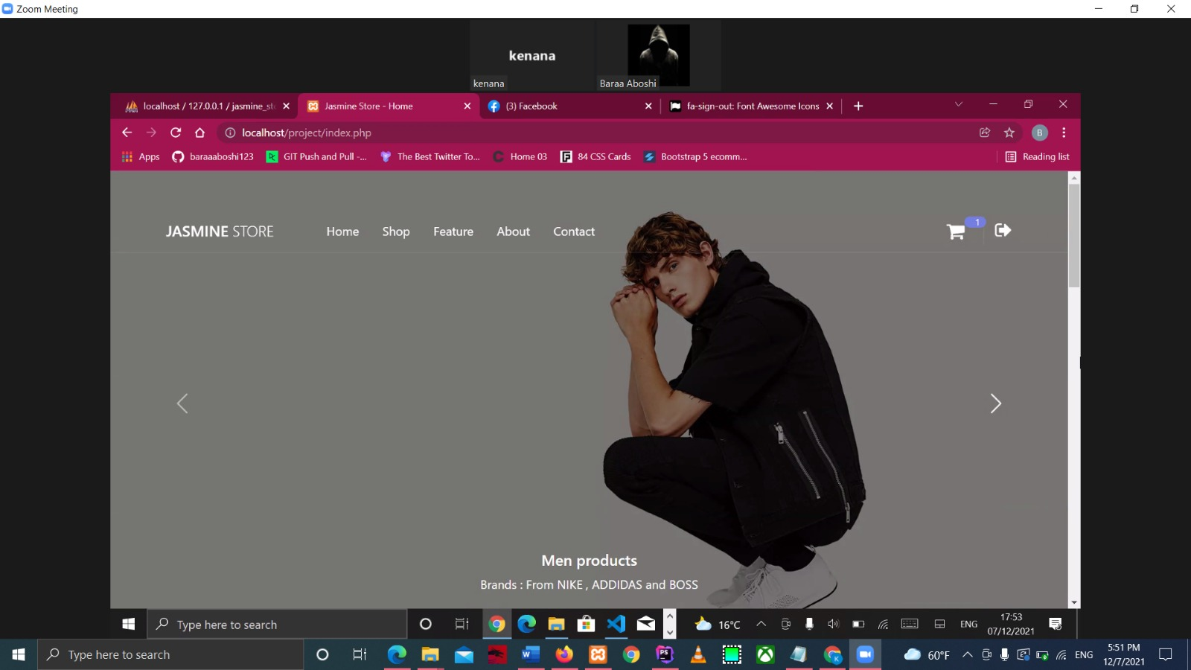

The carousel contains data about brands and categories .

* + Home Page : This page shows main categories of the store which are : Women, Men, Accessories, Shoes and Bags.

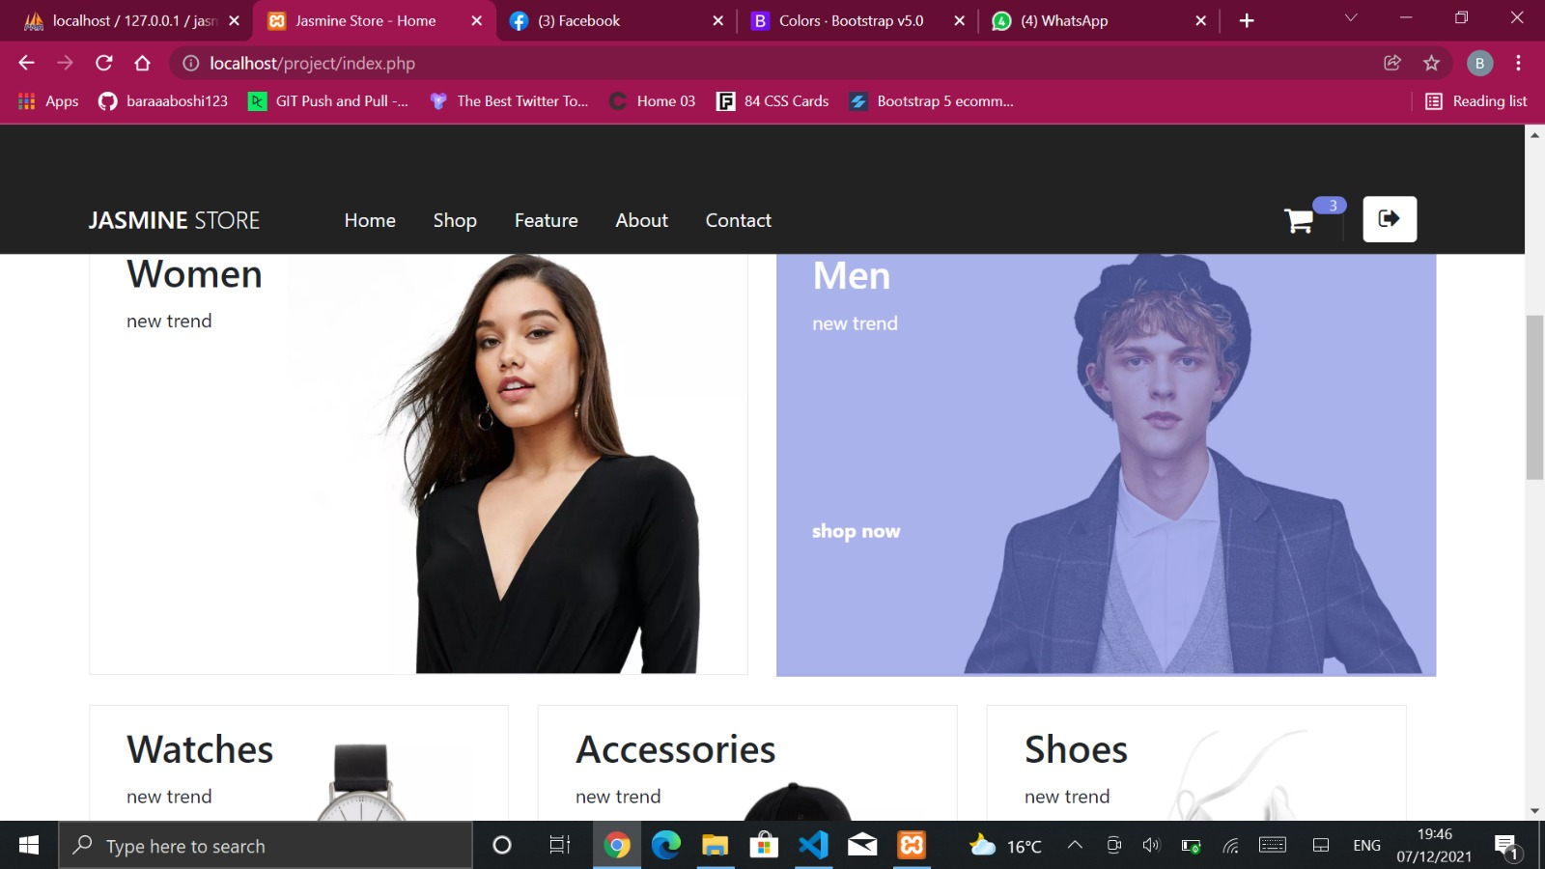

The navbar colour changed after scrolling down as shown below and the categories have hover as shown.

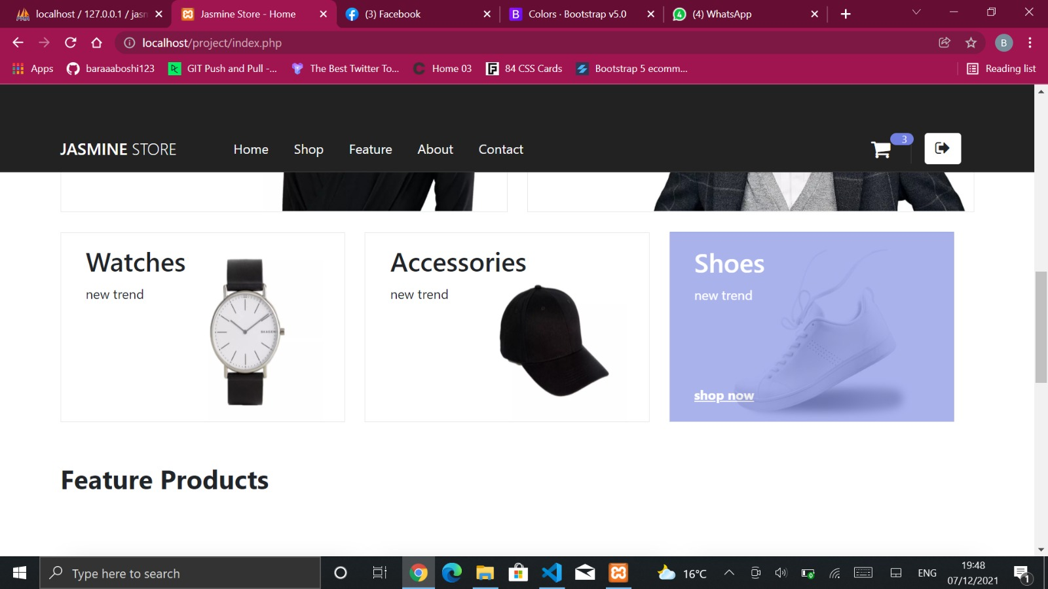

When user click on one of the categories he/she will be moved to the shop page .

* + Shop Page: This page shows products according to what options the user selects (all product , women , men , accessories, shoes or watches)

If user click on watches forexample just the watches will appear.

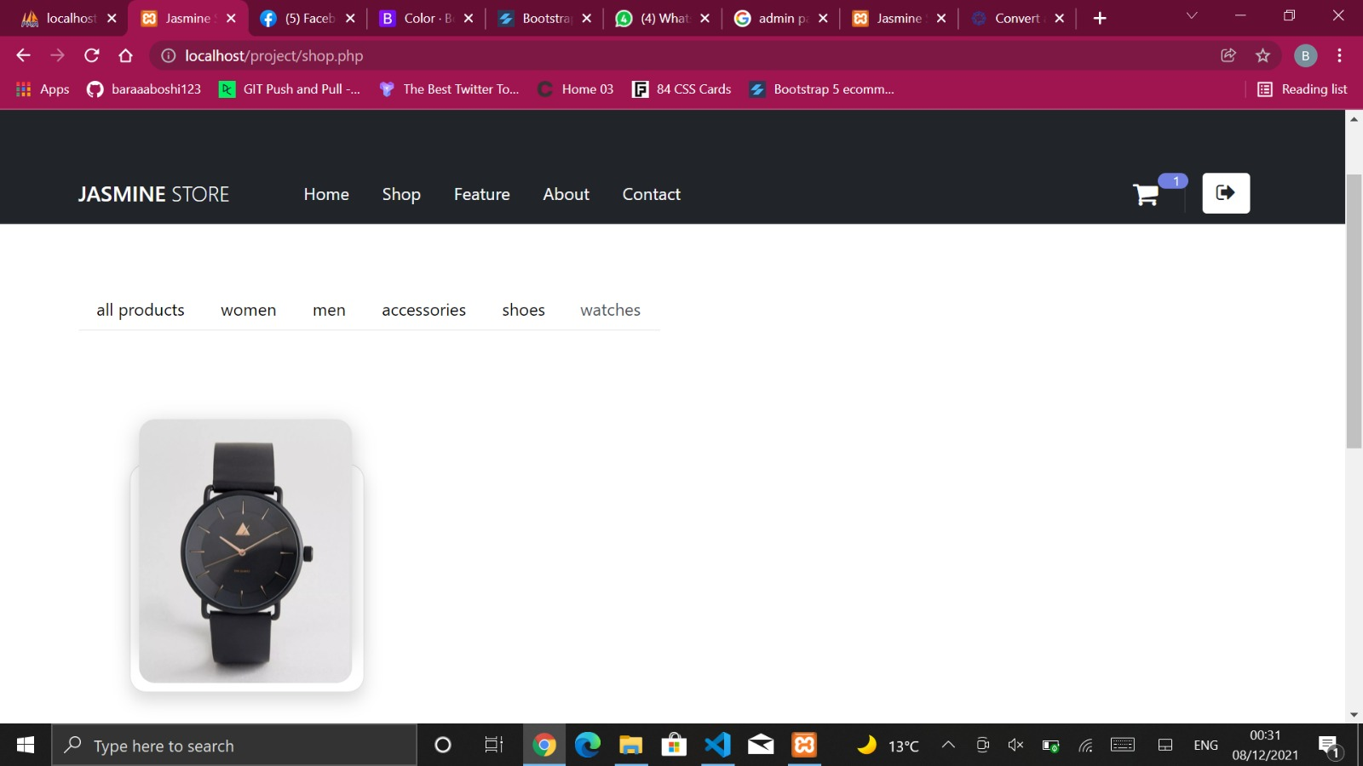

And the same for all the other categories (accessories,shoes,men And women)

But if the user click on all products : products from all types will appear

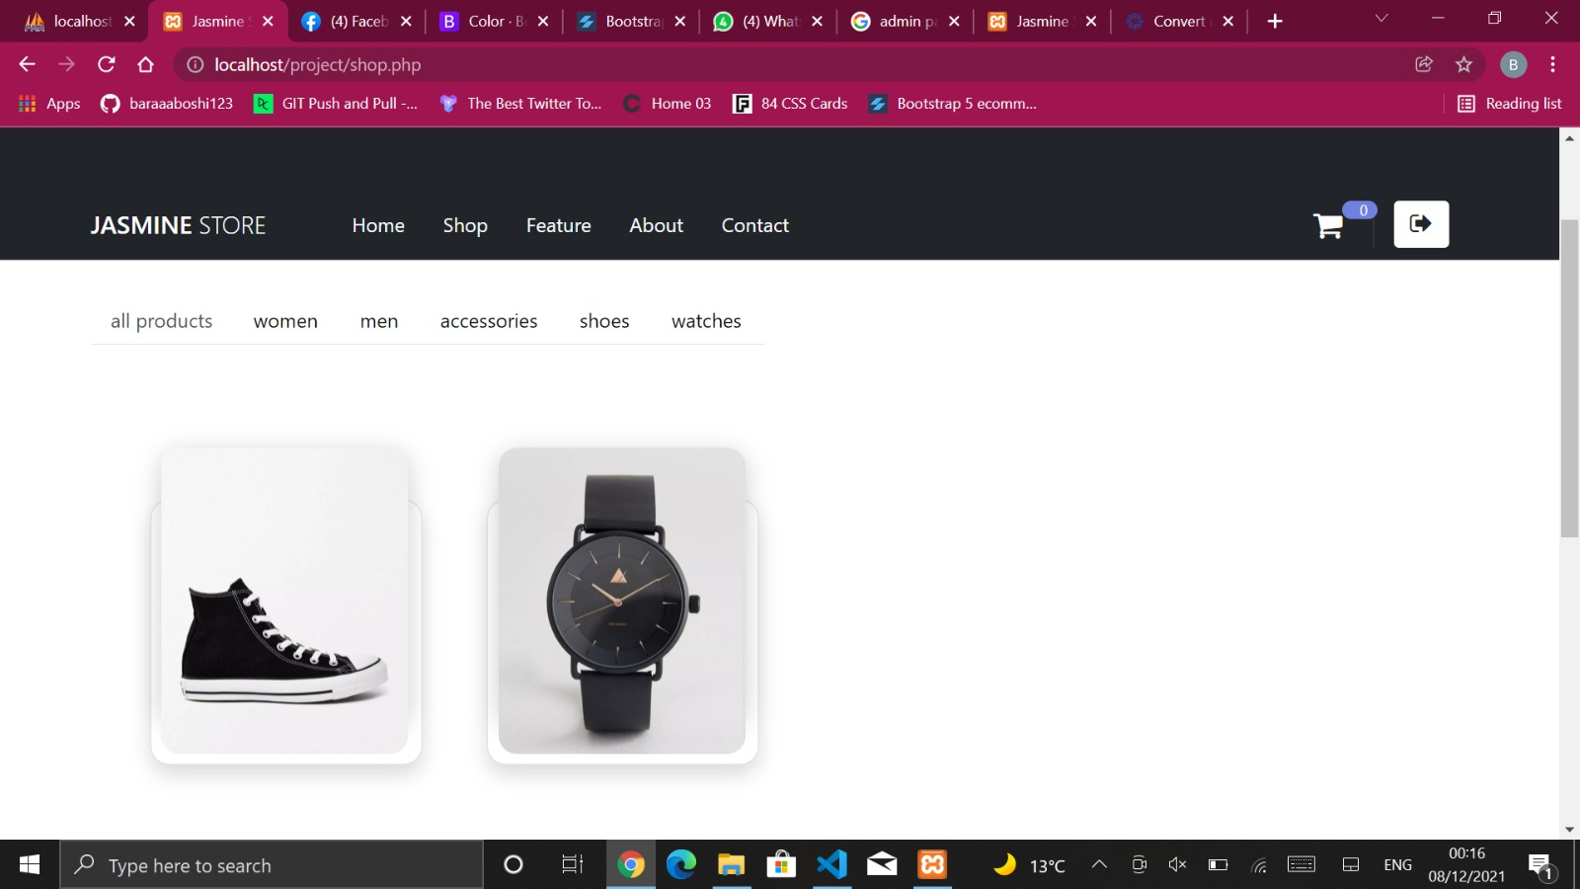

Note : Cart at first was zero

When user click on any of the products he/she will get view button as shown below.

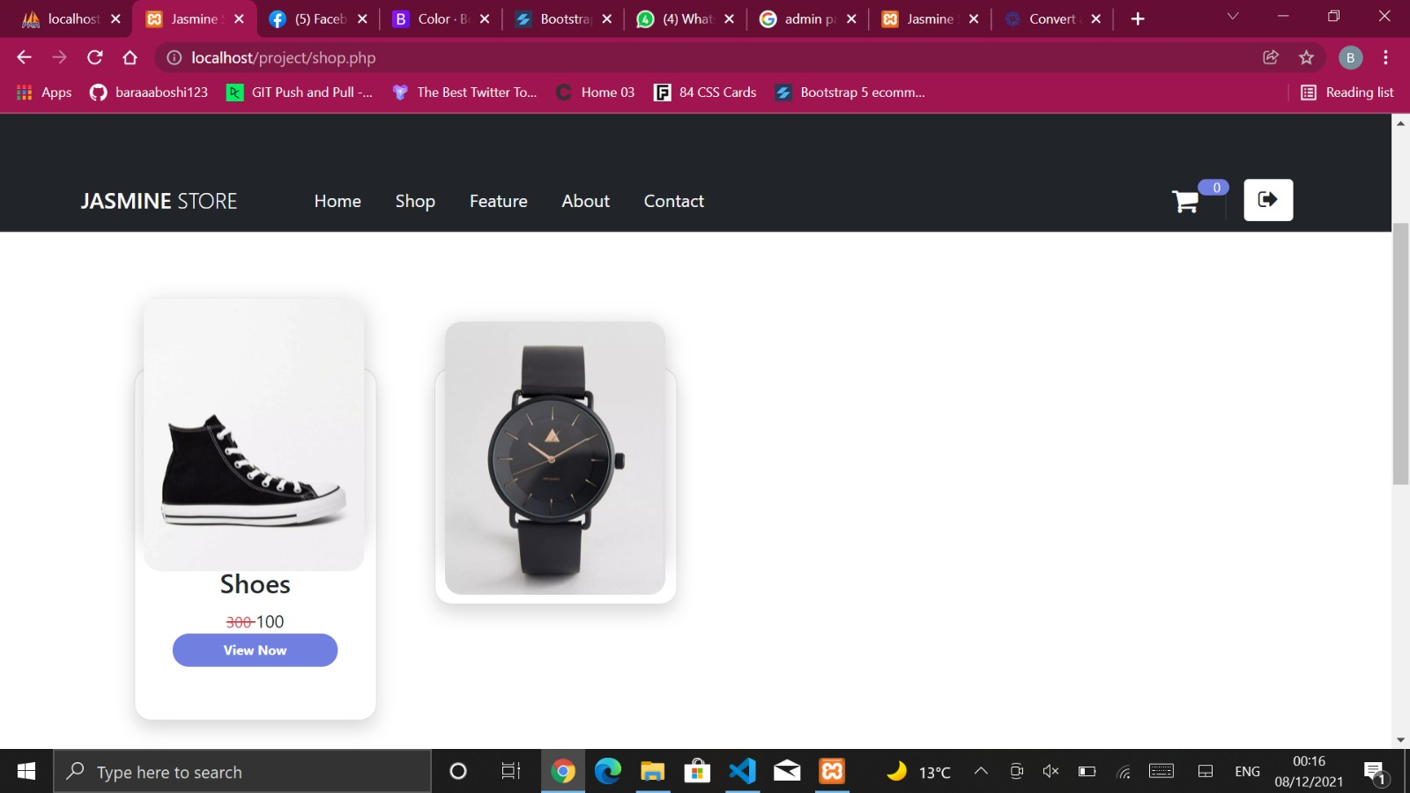

When user click on the button an pop-up menu will appear which shows all of the product information as shown below.

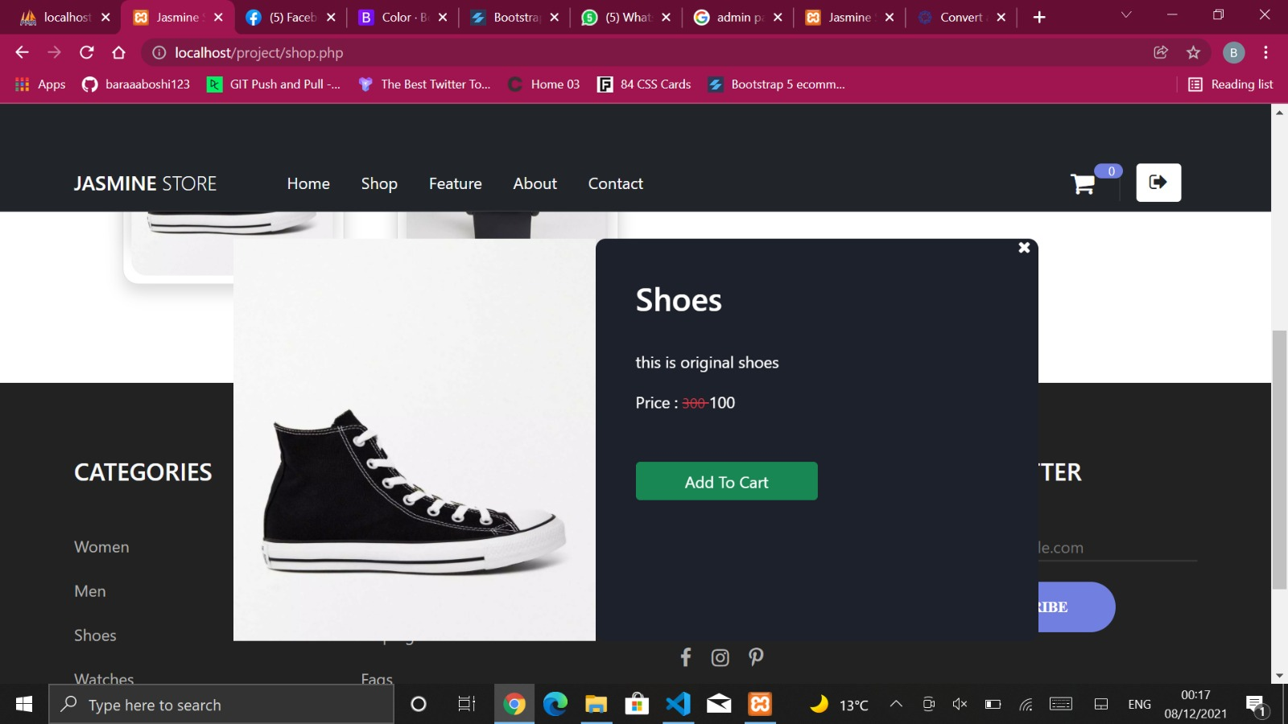

and if the user click on Add to cart the product will be moved to the user cart as shown below And If user open My cart this page will appear which gives the user the ability to confirm the order and insert the required countatity or remove the order from cart.

Note : there will be increment to the cart (in our case we have 2 procucts in the cart so number 2 will appear beside My cart icon ) and also all the details of the orders will be recorded in the right as shown.

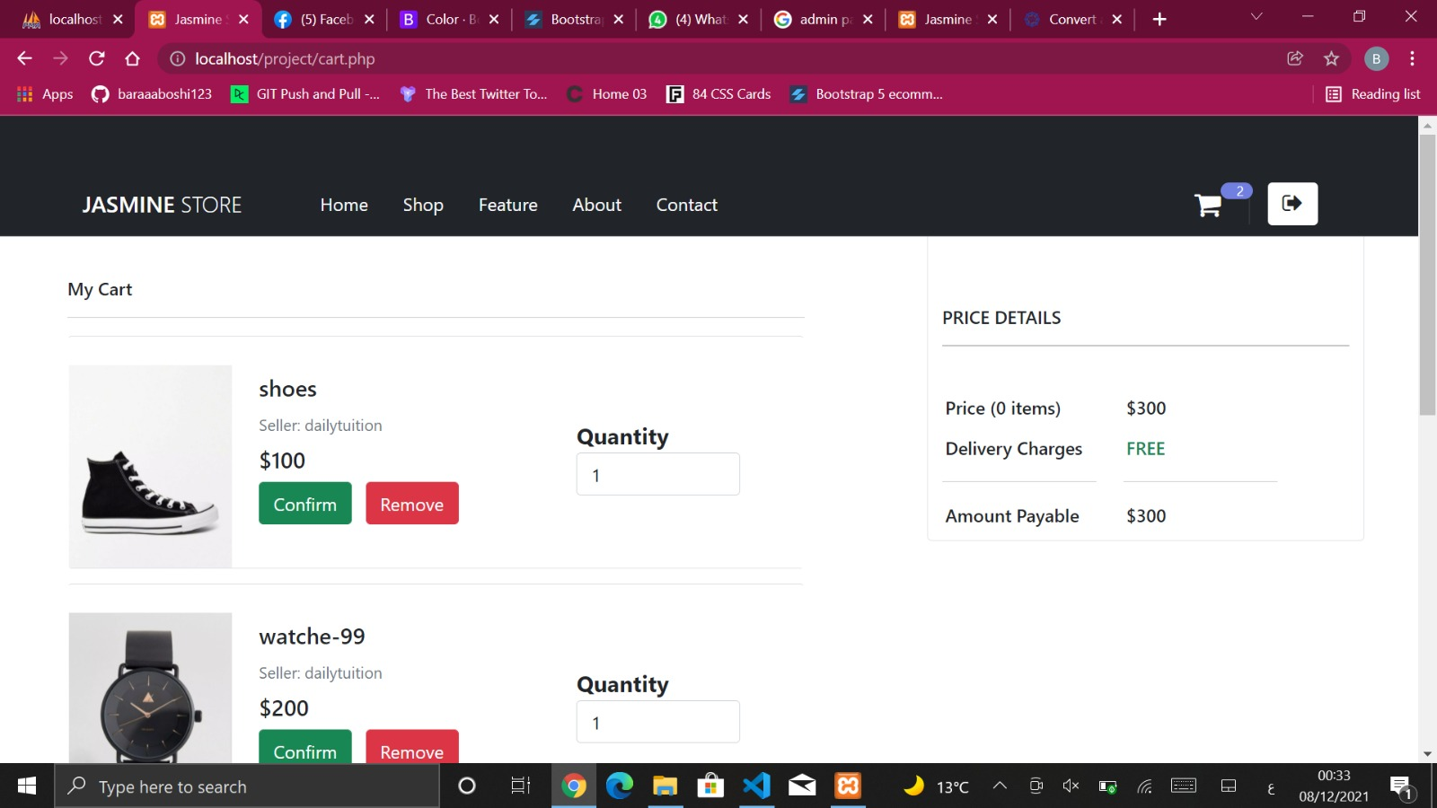

If user click on remove this message will appear

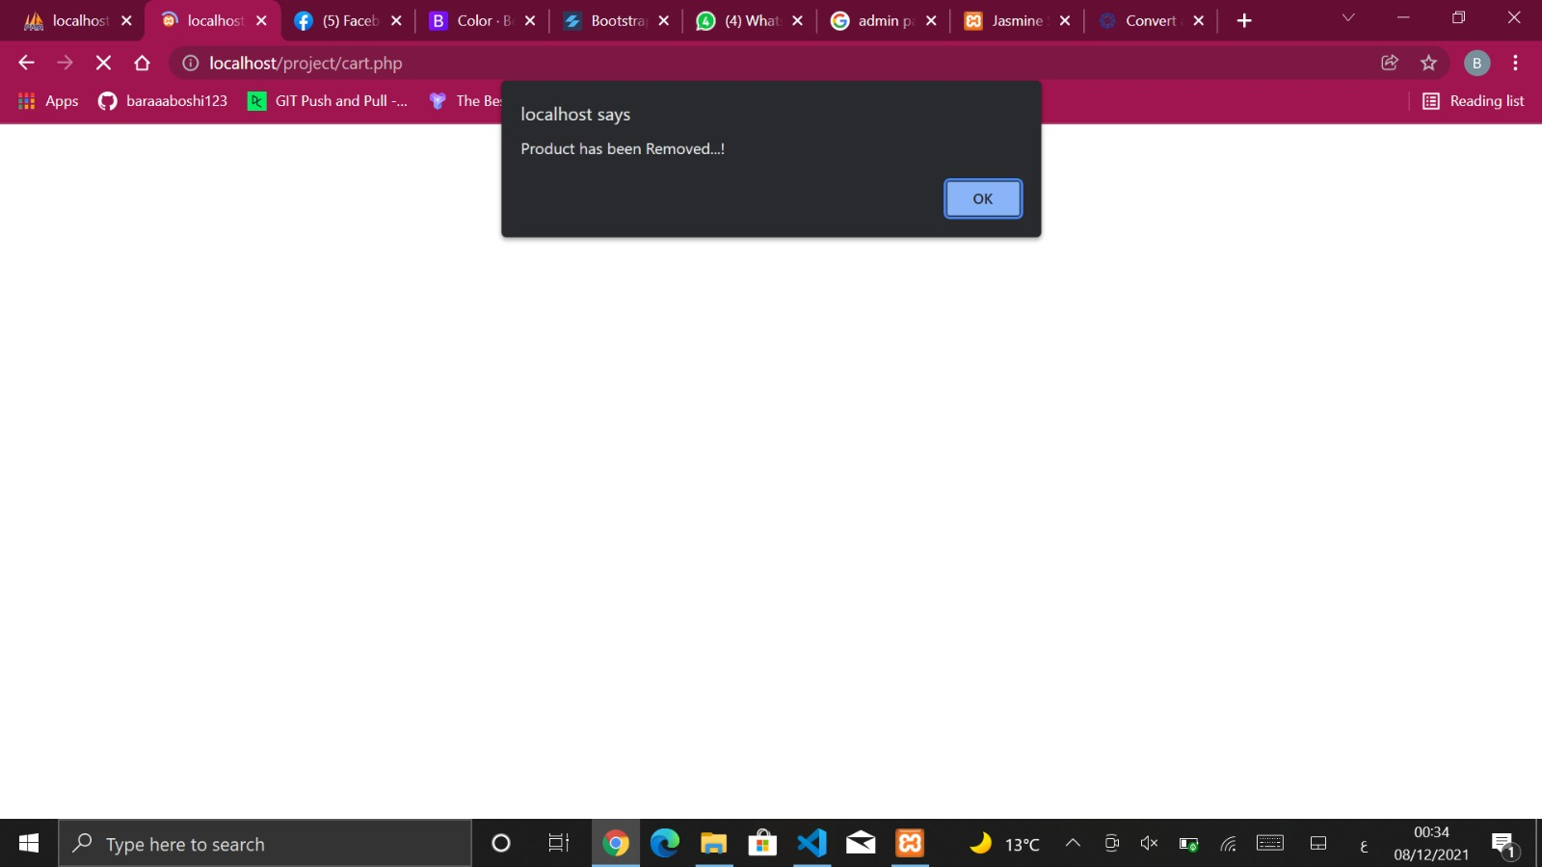

The following pic shows how the cart decrement by one after removing an item (shoes).



But if user click on confirm an pop-up menu will appear and he/she should enter phone number and address .

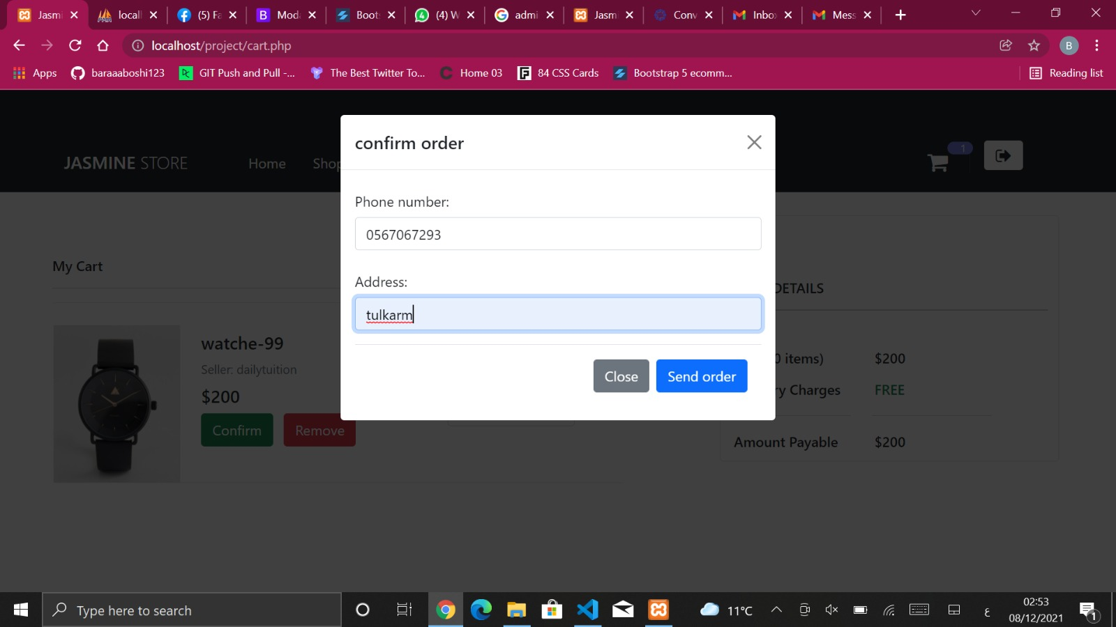

After clicking on send oreder this message will appear

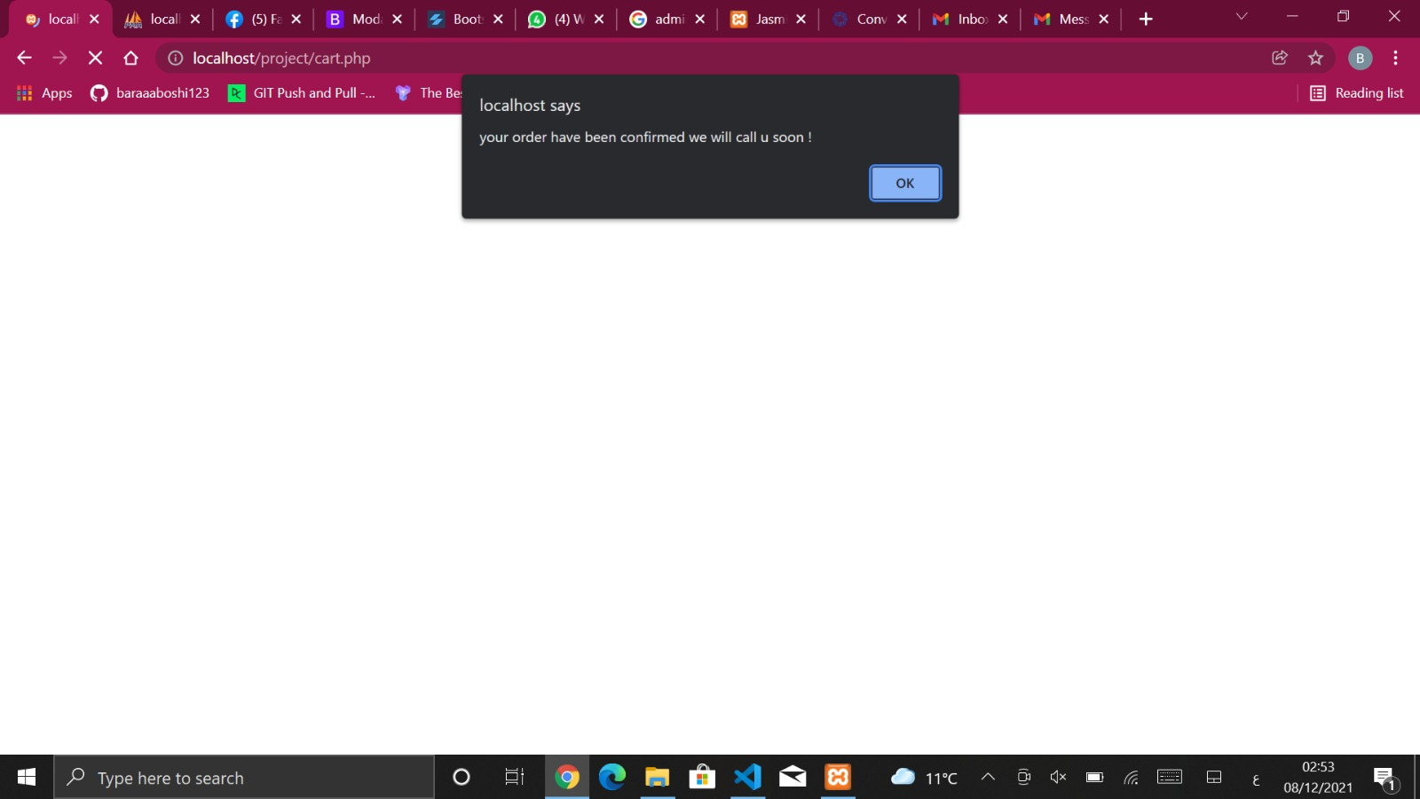

And the order will be added to shipping table in the data base as shown

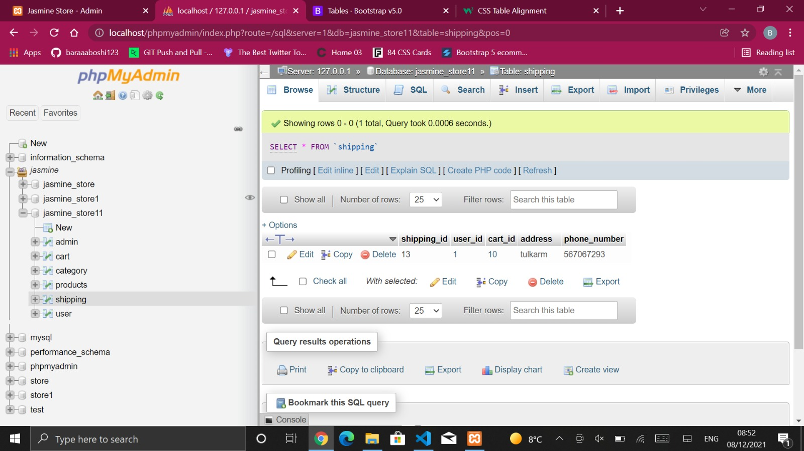

* + Feature Page: This page shows the discounts on the products as shown below

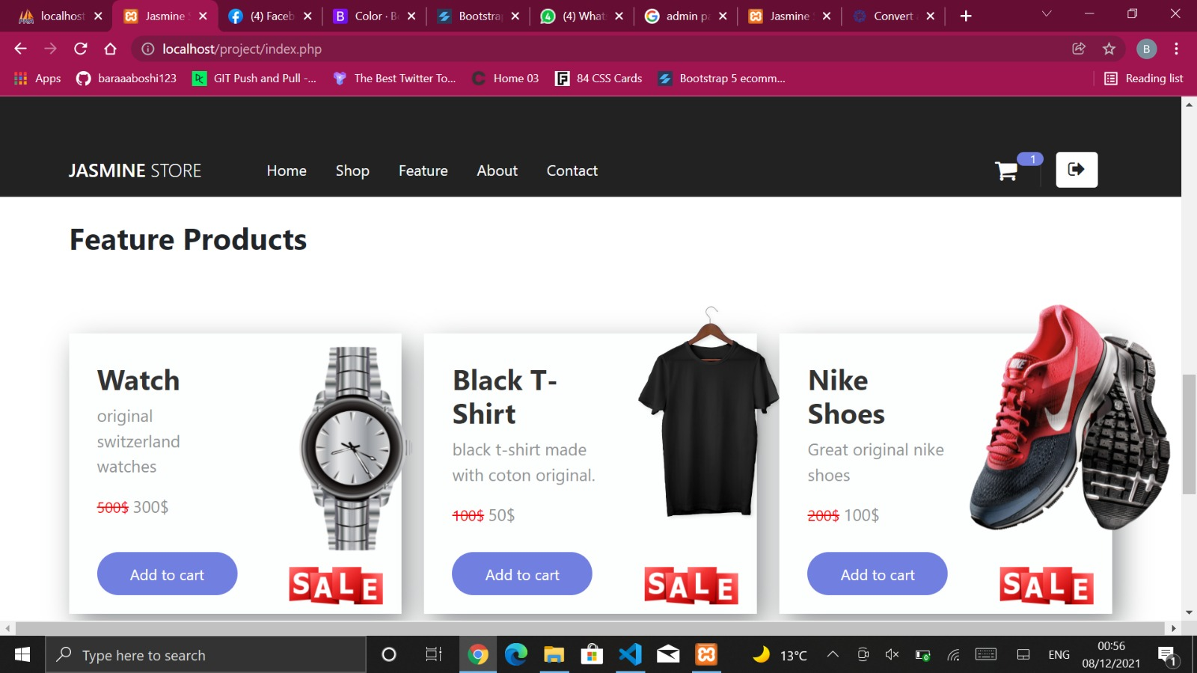

* + About page: This page contains general information about the store and what it provides also answers for some famous user’s questions.

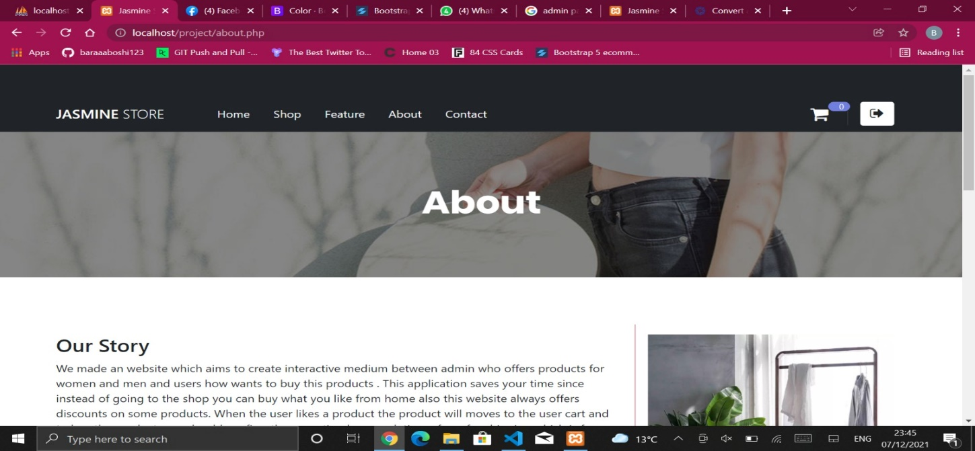

Note : The pictures apperers inside borders as shown below.

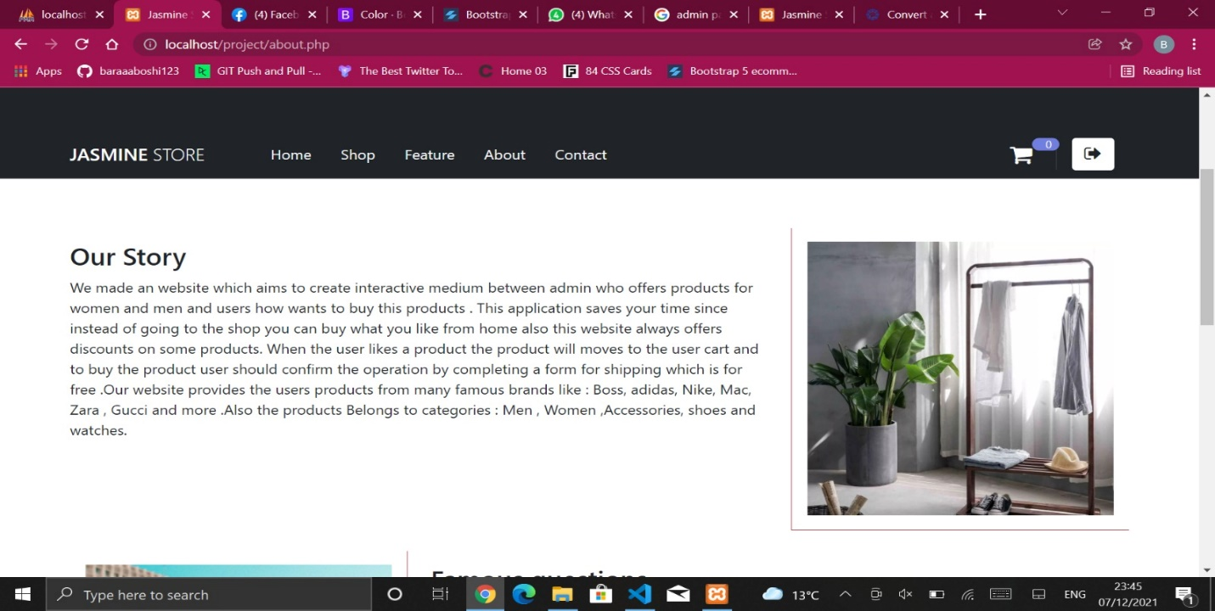

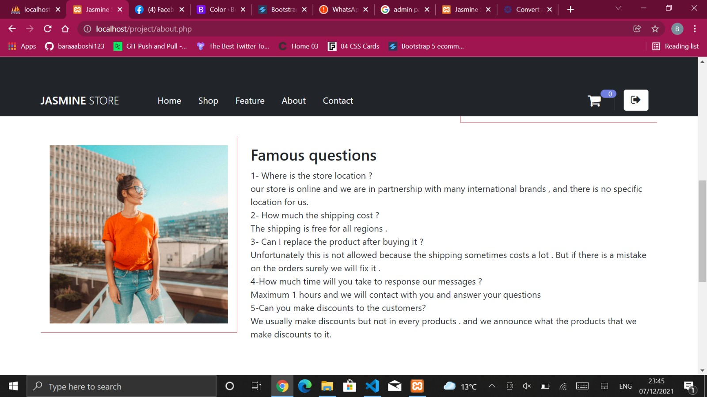

* + Contact page : This page shows a contact form between user and the website

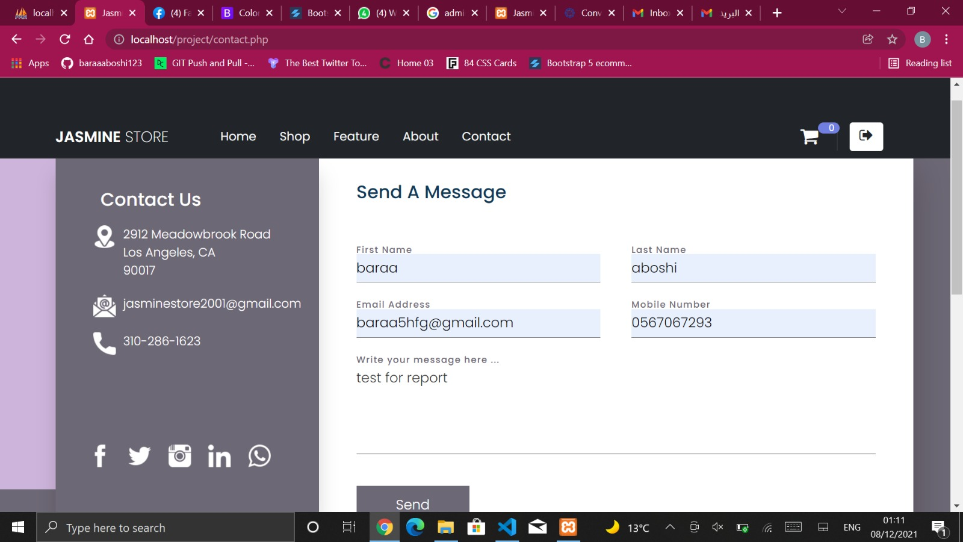

After sending the email this message will appear .

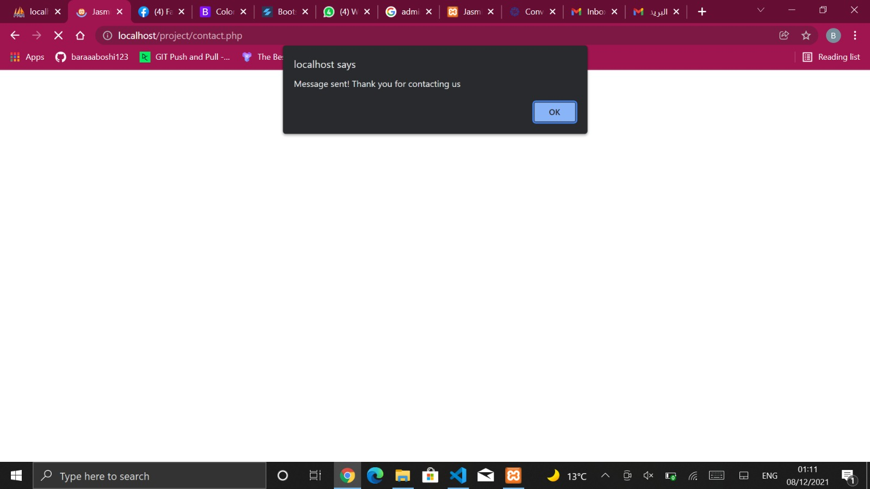

And the message will be sent to the website email sucessfully .

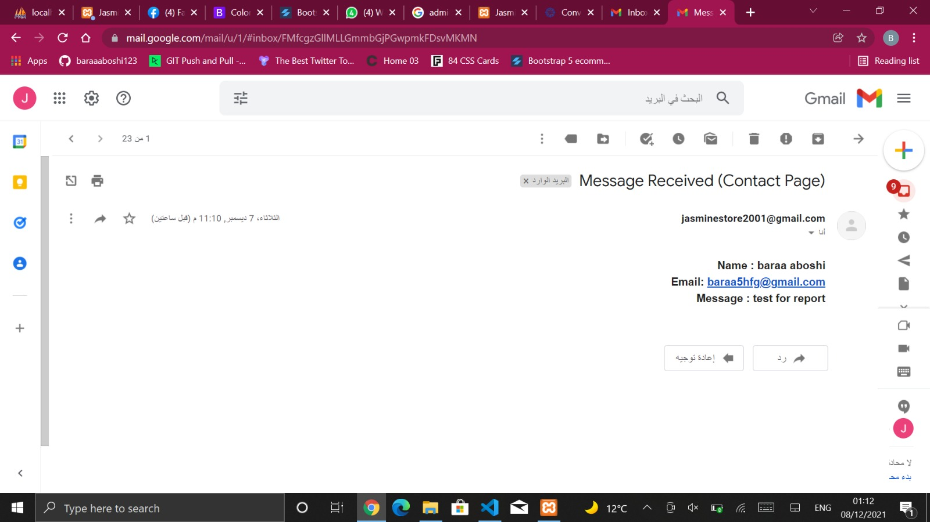

* Admin Login : If the inserted email and pass matches with the admin data then admin account will open . And it contains all of the User page contents plus 3 more options 1st one for shipping and the 2nd for adding items and the 3rd for Add Features .

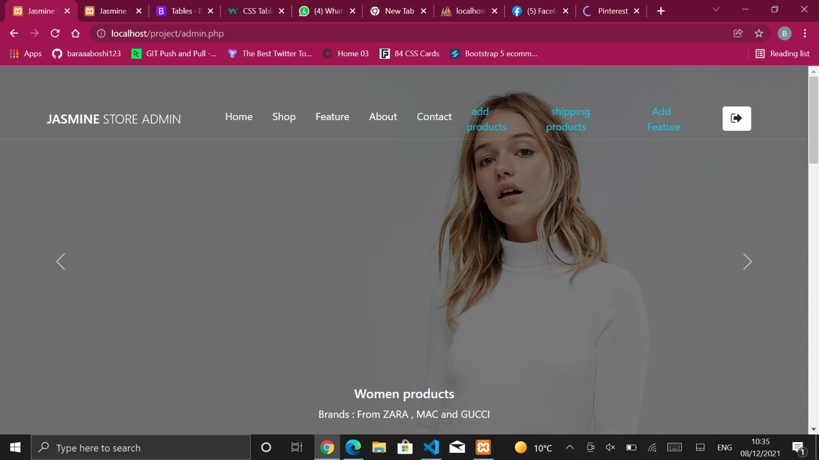

* + Add products : If click on add product this form will appear so admin should enter product info.

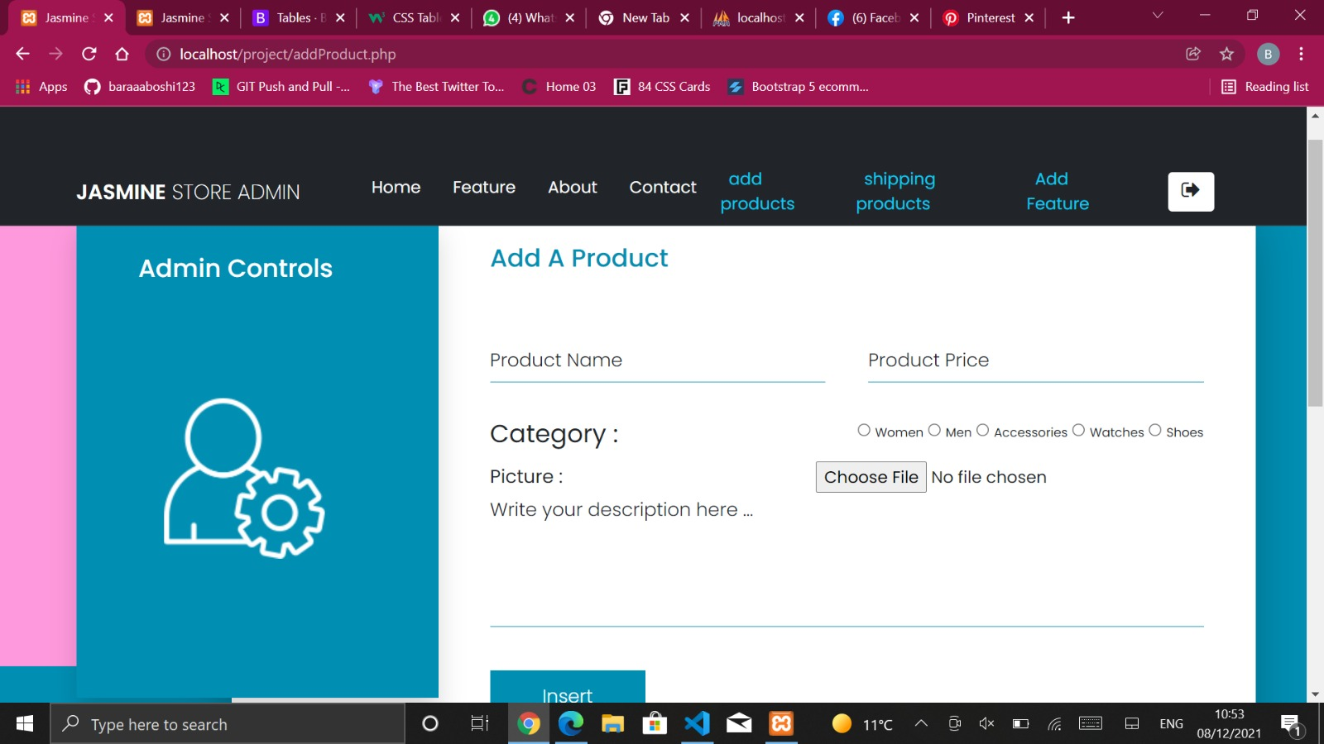

After click on insert this message will appear

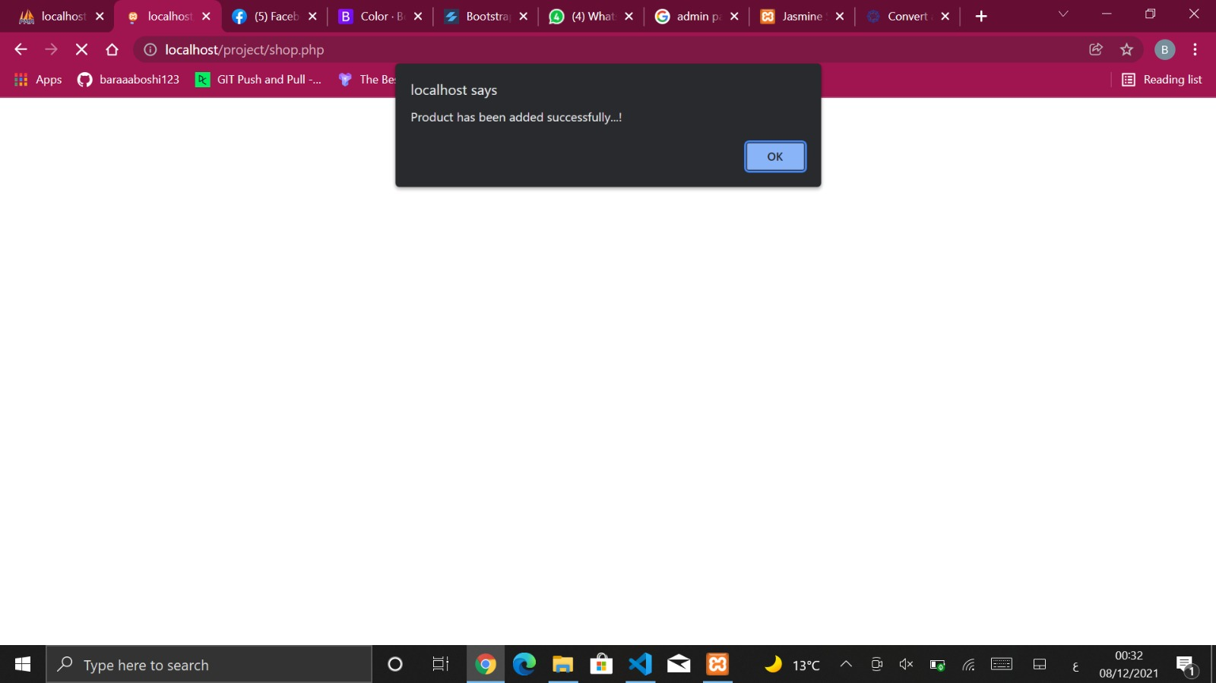

And the product will be added to the product table in the data base .

* + Shipping products : All of the shipping details (The confirm products) in the website will appear in the admin page here

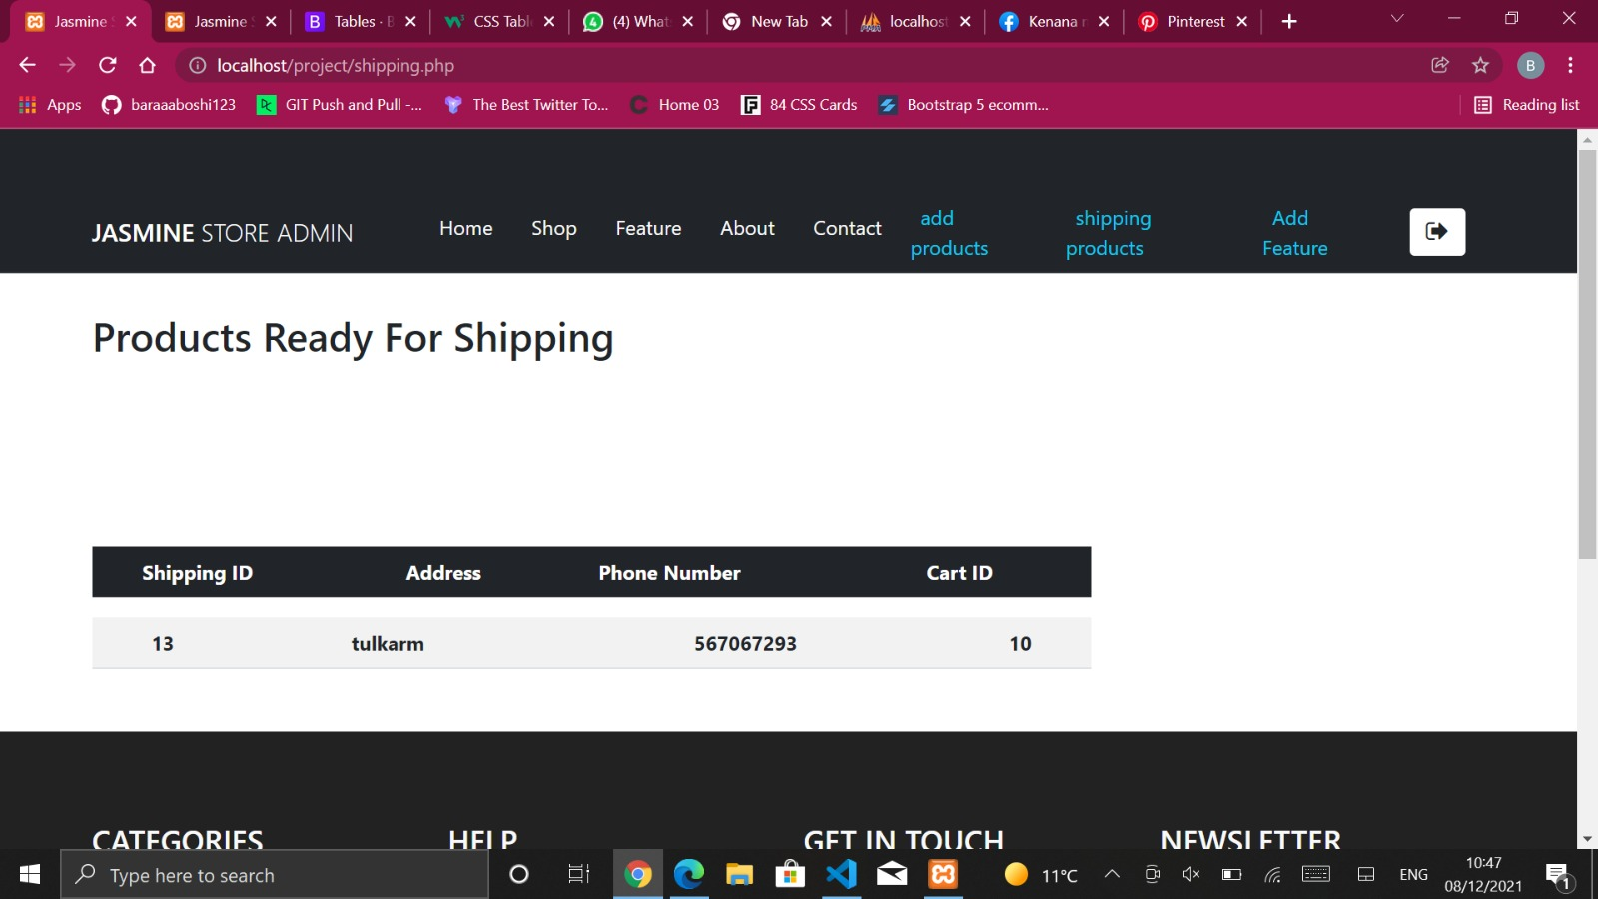

* + Add features : If admin click on add feature this form will appear so admin should enter product info.

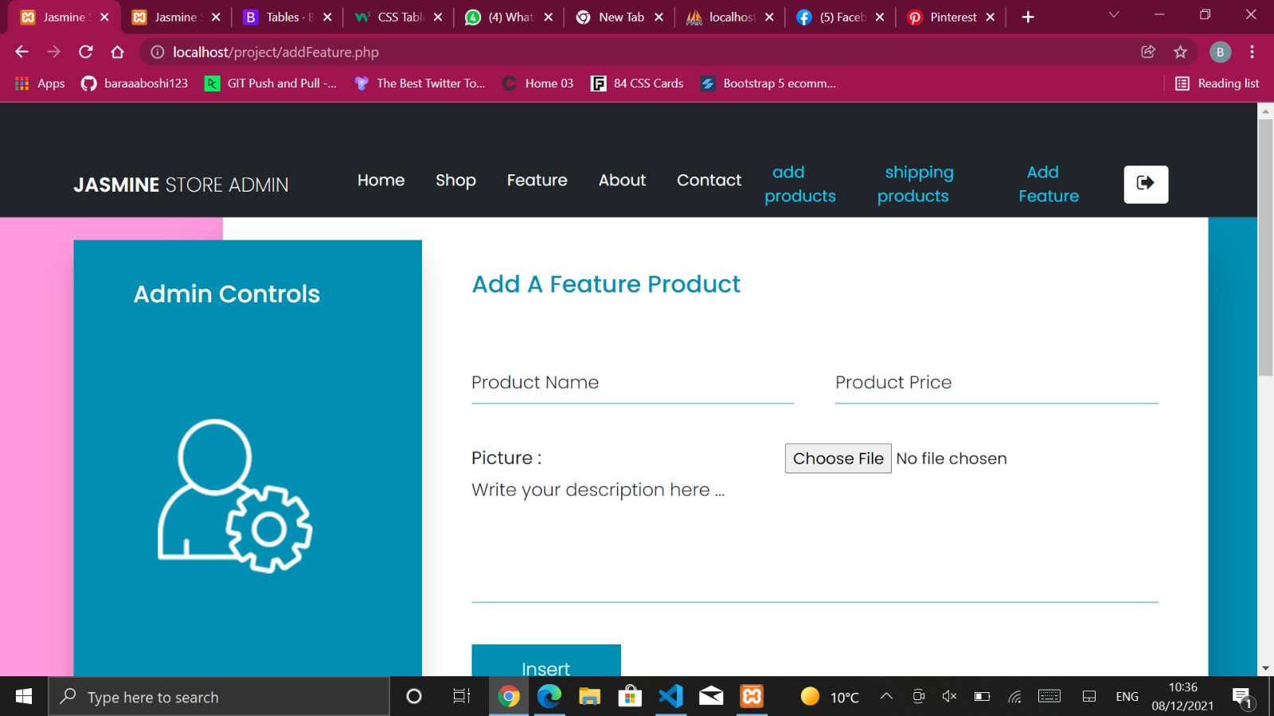

After click on insert this message will appear



And the feature after insertion will be added to the feature table on the data base and will look as shown below in the feature page.

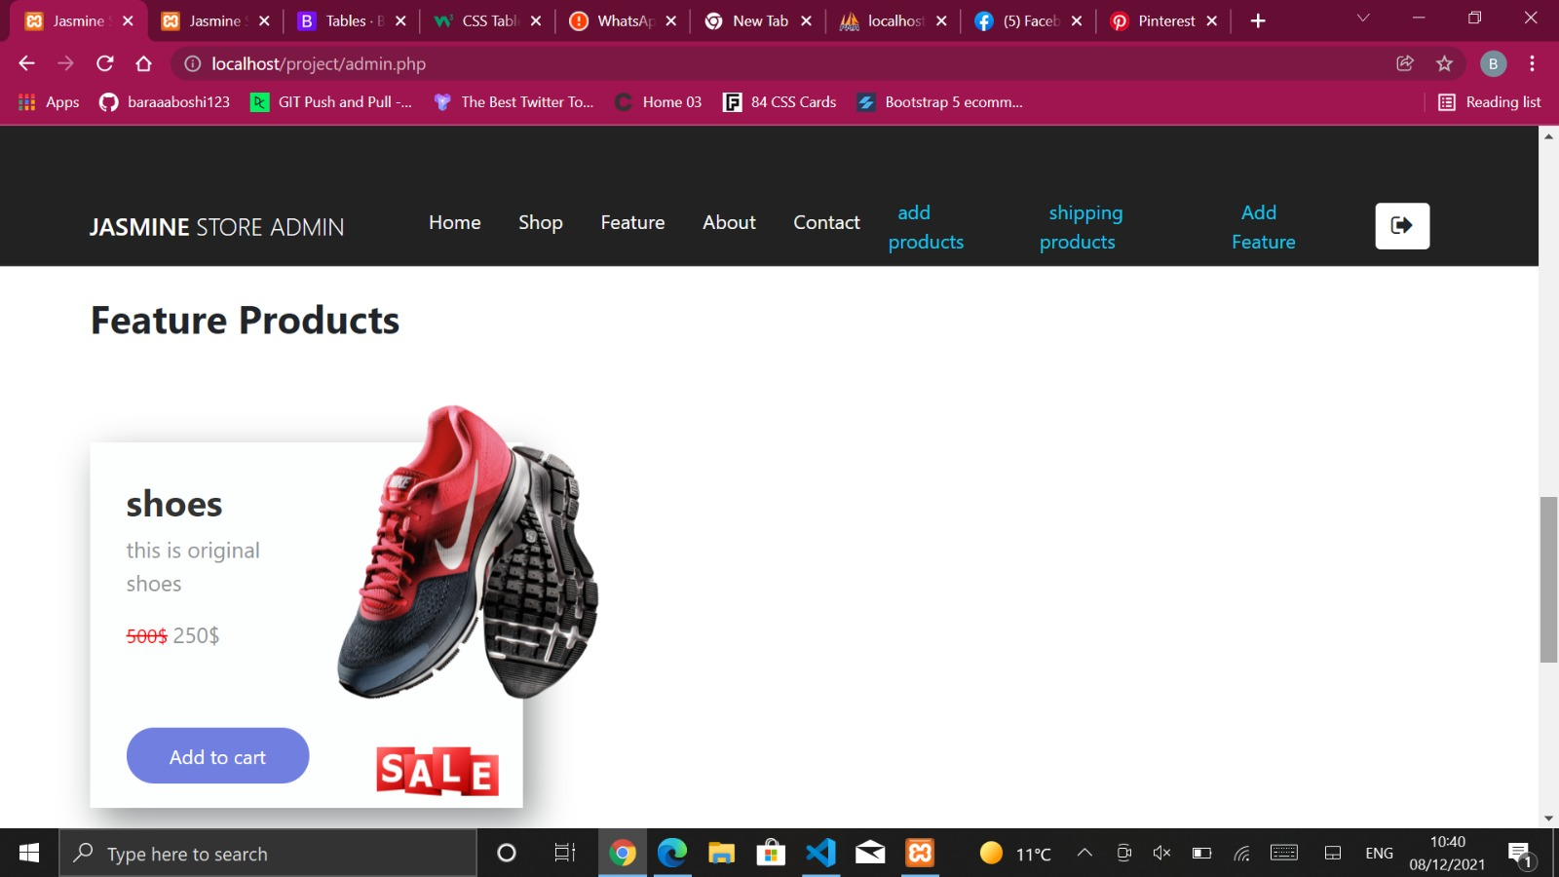

* Navbar and footer : appears on all of the website pages .

Red square: navbar

Blue: footer

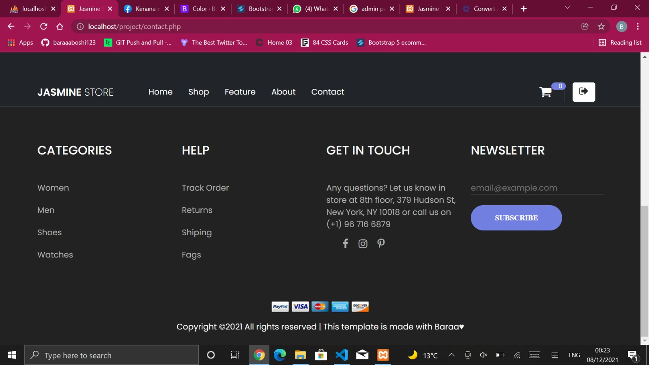

**Conclusion:**

Due to the development of technology now adays , Jasmine Store Online website was very useful because it saves customers times and efforts .Let them interact and contact with the store from their places anywhere in the world through a Nice interactive medium.

**References:**

1. Dr. Sufyan Samara slides and lectures .
2. W3schools
3. Stack overflow
4. Youtube channels :
   * CodeFlix
   * Weblesson
   * PhpMyAdmin
   * DCodeMania
   * OnlineTutorials